**crass-like Bacteriophages and their association with children obesity and metabolic syndrome**

Adrian Ochoa Leyva1*.

Affiliations:

1 Departamento de Microbiologia Molecular, Instituto de Biotecnologia, Universidad Nacional Autonoma de Mexico, Avenida Universidad 2001, Cuernavaca, Morelos, C.P. 62210, Mexico.

†These authors contributed equally to this work.

*Correspondence: [aochoa@ibt.unam.mx](mailto:aochoa@ibt.unam.mx)

**Introduction**

Recent advances in protocols for viral metagenomics and data maining (cita STAR) allowed us to known that the gut virome is mainly dominated by bacteriophages 19,20. Indeed, there is Disease-specific changes of the virome in inflammatory bowel disease26,28,AIDS29, diabetes30, malnutrition31, obesity, and obesity with metabolic syndrome (iScience). There are many reasons to study the relationship between phages and microbiota, the fact that they kill specific bacteria and transfer different genes, consequently, they can alter the host relationship with the microbiota (<https://www.ncbi.nlm.nih.gov/pmc/articles/PMC7551546/>). In human feces has been estimated at 10e9 VLPs per gram of feces (cita iscience). Although, there are “passenger viruses” that are diet-associated, such as plant and dietary viruses [7,8 del trends y poner el minot].

Since their discovery in 2014, crAss-like phages are one of the most intriguing elements of the human virome [3, 6, 10, 11], being one of the most abundant gut associated-virus <https://doi.org/10.1038/ncomms5498>, and also is a common component of the gut virome across the human population (cita global phyleogeography and Mexican-crass), showing a considerable genomic diversity (biology_and_taxonomy). The crAss-like viruses appear to have coevolved with humans [https://www.nature.com/articles/s41564-019-0494-6]. Indeed, crAssphage is associated with several non-human primates populations globally distributed (cita global phyleogeography).

The crAss-like phages also appear to be abundant and widespread in diverse habitats, both animal and environmental human associated (<https://doi.org/10.1038/s41564-017-0053-y>.). Several bacteria of the phylum Bacteroidetes appear to be the primary hosts of crAss-like phages, being the 0CrAss001 the first crass-like member isolated and infecting the Bacteroides intestinalis (<https://www.nature.com/articles/s41467-018-07225-7>). Recently, taxonomy of crAss-like phages composed of four subfamilies and ten generas was proposed (biology and taxonomy). These phages are normally scarce in the feces of one-month infant, increasing their abundance in the four-month and the 2-5-year-old infant and becoming a high-level persistence of different combinations of crAss-like phages in adults (<https://pubmed.ncbi.nlm.nih.gov/31600503/>). Indeed, the crass-like clade is detected in both the mother and the infant, suggesting vertical transmission and can be also acquired through fecal microbiota transplantation (<https://www.nature.com/articles/s41467-019-14103-3>). These discoveries have stimulated the experimental study of crAssphage-like phages also as an indicator of human fecal pollution (Cinek et al., 2018; Stachler et al., 2017). Indeed, despite the high interindividual variotions in the gut virome (cita Iscience), the crAssphage constitutes a global virus marker for global scale studies (citar nature microbiology phylogeography) and it is part of the human virome core (citar review último).

Recent research suggest that crAssphage prevalence is associated with an industrialized lifestyle/diet, but with no associations to health, age, sex, or body-size variables (citar plos one y el biology and taxonomy). CrAssphage abundance was also not associated with diseases such as diarrhea (chinos), CD, HIV, IBD, T2D and malnutrition (plos one y biology and taxonomy). However, a recent study showed that the crAssphage was more abundant in the healthy controls than colorectal cancer, suggesting a promising potential treatment strategy for this disease through fecal CrAssphage transplantation in the future (<https://pubmed.ncbi.nlm.nih.gov/34307189/>). Contrary, the abundance of crAss-phage was significantly increased in UC patients than in normal control (cita QYSX). Nonetheless, as major components of the human gut, crAss-like phages deserve more attention and the association with specific diseases shall be further investigated. There are no studies addressing the role of crass-like group in obesity and metabolic syndrome. Clearly, the study of this expansive group of viruses is still in its infancy, and fundamental features of these major players in the human virome as well as their actual spread in the biosphere remain to be studied (citar review 2020).

In this study, we explored the role that crAss-like group has in obesity and metabolic syndrome to better understand their biological significance. Further, we evaluate crAssphage abundance, as a function of gut bacteria, anthropometric and biochemical parameters typically altered by obesity and metabolic syndrome.

**Results.**

**1. Different proportion of crAss-like genomes were detected at the same sequencing depth.**

We used the viral metagenomics data of 28 fecal samples from a previously described cohort from 7- to 10-year-old children, 10 healthy normal weight (NW), 10 with obesity (O), and 8 with obesity and metabolic syndrome (OMS) (iScience) (Table X).

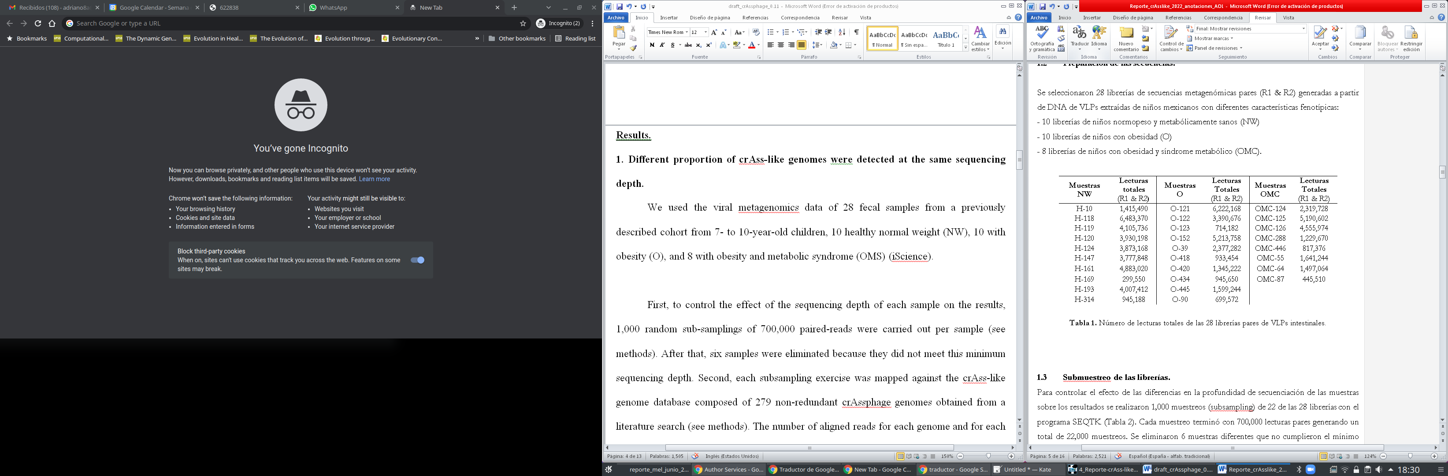

First, 1,000 random sub-samplings of 700,000 paired-reads were carried out per sample (see methods) to normalize the sequencing depth for all samples. This subsampling exercise was used on further analysis. After that, six samples were eliminated because they did not meet this minimum sequencing depth. Subsequently, each subsampling exercise was mapped against the crAss-like genome database composed of 249 non-redundant crAssphage genomes previously validated by Guerin et al 2018 (see methods). The number of aligned reads for each genome was calculated as the average of these 1,000 mapping exercises for each sample. This normalized read-counts table was used for further analysis. Three samples were eliminated for having less than 12 aligned reads to crAss-like genomes. After that, only 6 samples from the NW group, 9 samples from group O and 4 samples from the OMC group meet the requirements to continue with further analyzes (Table X).

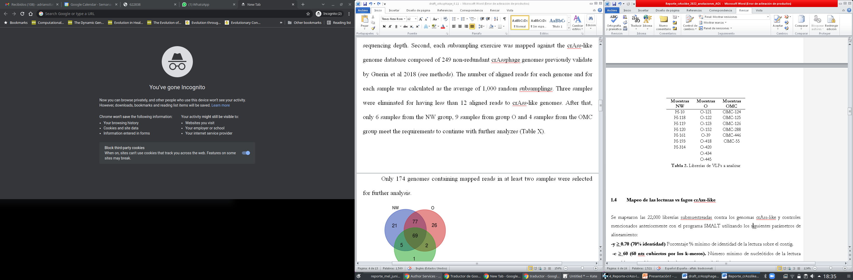

From the 249 crass-like phages, only 201 genomes contained mapped reads and these genomes were selected for further analysis. Using a Venn digram we can found that 69 phages were shared among the three groups. We also found unique phages for each group (figure x).

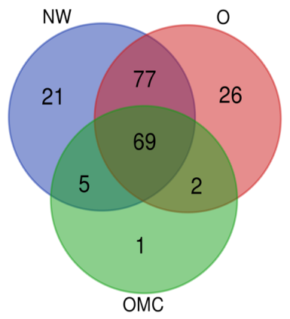

The relative phage abundance ranged from 0.0007 to 3.607% of total reads per sample (Figure X1).

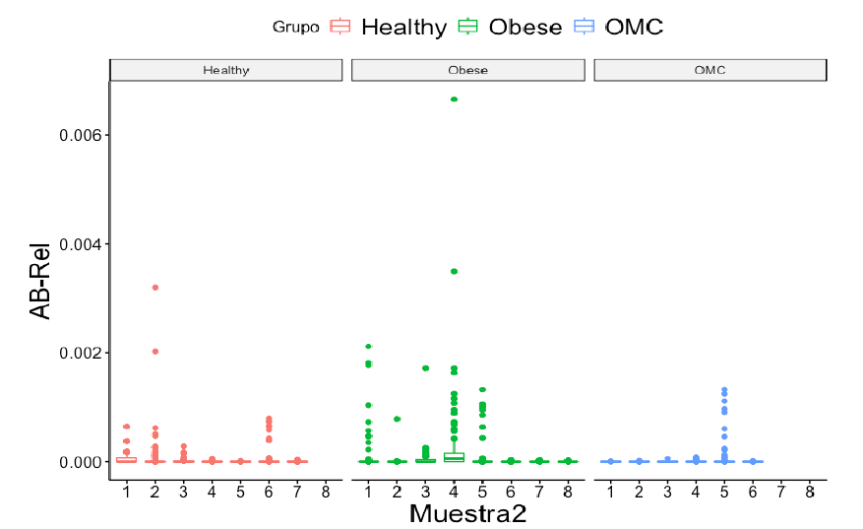

We also found a tendency to decrease of crass phage abundance in obesity and metabolic syndrome compared to NW (ver figura abajo). However, the difference was not significant,

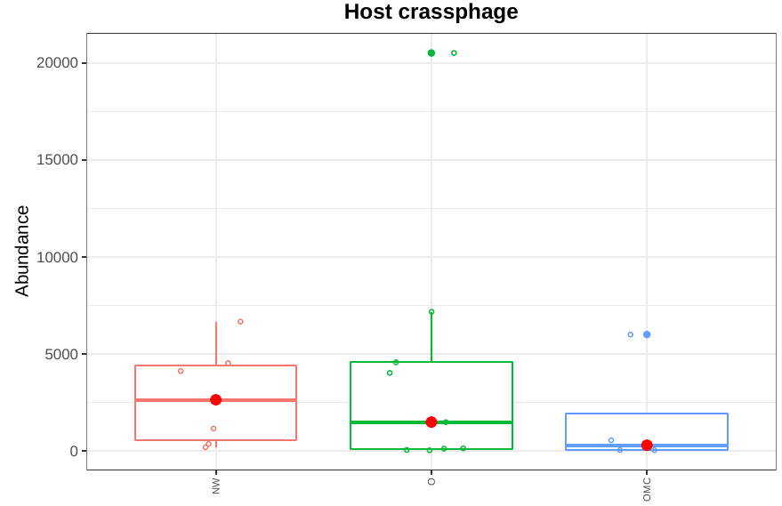

**2. Taxonomy of crAsslike Bacteriophages**

We classified the genomes following the criteria described by to Guerin et al. 2018, into four subfamilies composed of ten genera. Thus, we calculated the relative abundance for each taxonomic level using the normalized reads-count table. We found a greater abundance of crAss phages of the Alpha and Delta families among the three groups. In the NW group a significant over-abundance of phages of the Alpha family was observed as compared to O and OMS (Figure X). An over-abundance of Delta was observed in obesity groups, however the difference was not significant. The Beta family was also significantly abundant on O as compared to NW and OMS (figure X).





|  |  |  |  |
| --- | --- | --- | --- |
| Familia | NW | O | OMC |
| Alpha | 0.0053182 | 0.00273940 | 0.00222299 |
| Beta | 6.8148E-05 | 0.00039956 | 0.00030637 |
| Delta | 0.00617164 | 0.0098874 | 0.01228717 |
| Gamma | 0.00019838 | 0.00054704 | 5.995E-05 |

At the genus level the Delta-7 represented the most abundant phages among the three groups, however no significant difference between groups was observed. Contrary, the Alpha_1 and Alpha_4 were significantly increased in NW as compared to O and OMS, and Beta_6 was significantly over-abundant in O as compared to NW and OMS. The Alpha_3 was over-abundant in O and OMS as compared to NW; however the difference was not significantly.







**3. Alfa diversity**

The normalized reads-count table to crAssphage genomes was used to analyze the alpha diversity among samples at 999 repetitions (see methods). The alpha diversities showed that phage diversity and richness decreased in O and OMS compared to NW (figure x), although the differences among groups were not significant.

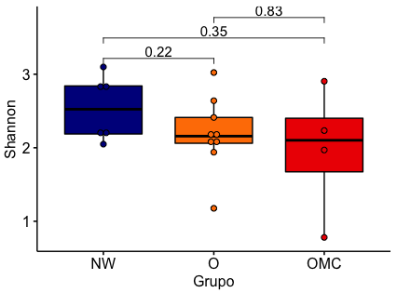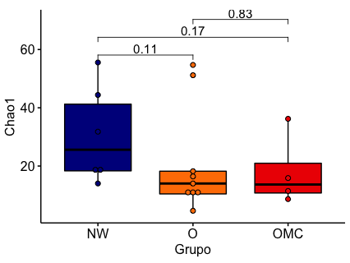

We also performed beta-diversity analysis to known if there was a clustering of crass-like associated with the disease; however not clustering was observed (Fig. Supl. X).

**6. Correlations of crAssphages with bacterial host**

We next assessed whether the abundance of the total crass-like phages was associated with a parallel change in important bacterial populations, which was suggested as possible hosts. To this end we selected the 16srRNA sequencing data of following bacterial taxa: Bacteroidales, Bacteroidetes, Collinsella, Bacteroides, Bacteroidia, and Prevotellaceae and calculated the Spearman correlation between them and the crass-like genomes in all samples. However, we do not found any significant correlation.

On the other hand, we analyzed the abundance of host bacterial taxa and found that Bacteroidetes, Bacteroidia and Bacteroidales were significantly decreased in O and OMS (Fig. x), suggesting a possible relation with the decreased abundance, richness and diversity of crAssphages.

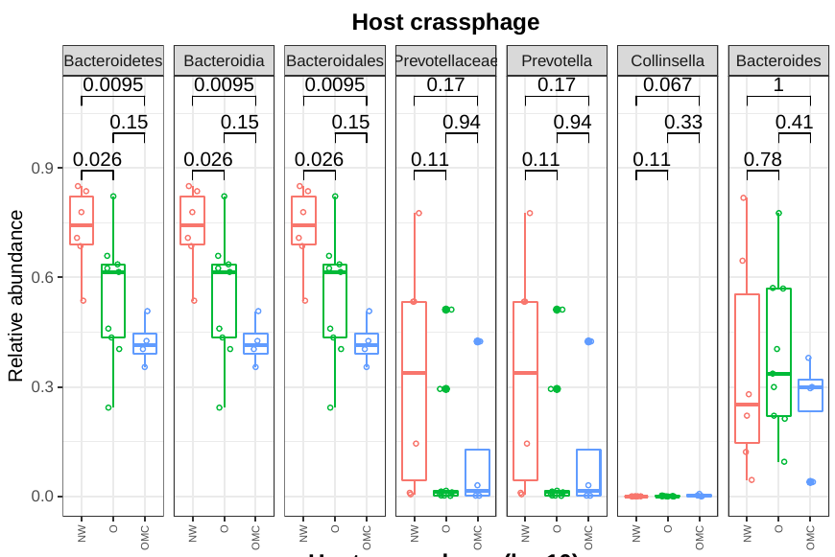

**7. Correlations of craSphages with microbiota and clinical and anthropometrical parameters altered by obesity and metabolic syndrome**

We also assessed whether all crAssphages were associated with parallel changes in bacterial populations previously associated with obesity and metabolic syndrome (cita meta). To this end, we calculated the Spearman correlation between the 16s rRNA gene sequencing data of 27 bacterial taxa and the abundance of all crAssphages in all the samples. Interestingly, we found a negative correlation between the abundances of crass phages and the order Bacilli (fig x). Bacilli were significantly more abundant in OMS than in NW.

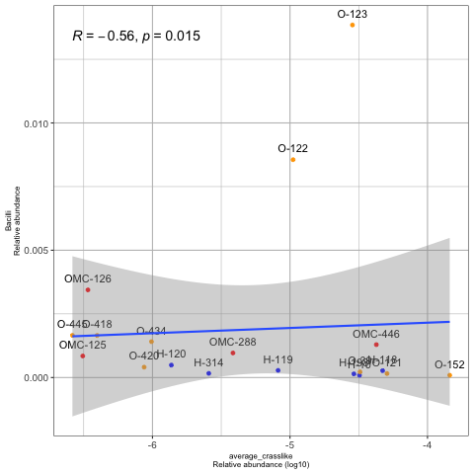 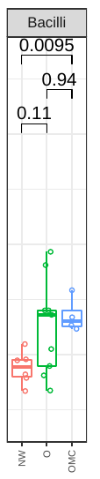

We also analyzed whether all crass phages correlated with the anthropometric and clinical parameters typically altered in obesity and metabolic syndrome, such as high body mass index (BMI), low levels of high-density lipoprotein (HDL), high levels of triglycerides, high glucose level, high waist circumference, and high weight (Gallardo-Becerra et al., 2020). However, we do not found any significant correlation.

**Discussion**

The crass-like bacteriophages have a special and central role in the gut virome, which are presented in almost all humans. The overall objective of this study was to gain insights into the potential role of crAssphages in children obesity. The quantitative analysis of the crass-like phage genomes revealed that the majority of our samples contained varied amounts of crAssphage DNA. Similar crAssphage abundances were reported in healthy Malawian infants (cita).

The host phylum for crAssphages has been hypothesized to be Bacteroidetes (<https://www.nature.com/articles/ncomms5498>). Further investigations has been also linked the taxas Bacteroidales, Collinsella, Bacteroides, Bacteroidia, and Prevotellaceae as host bacteria of crAsslike-phages. Specifically, two crAssphages has been isolated in pure culture the ΦcrAss001 and ΦcrAss002, infecting Bacteroides intestinalis and Bacteroides Xylanisolvens, respectively. In this regard, we tested if the abundance of these bacterial taxa were correlated with the crAssphage abundance in our samples. However, we do not found significant correlations between the abundance of crass and its hosts. Nonetheless, it is interesting that a significant decrease in the abundance of host taxa such as Bacteroidetes, Bacteroidia, and Bacteroidales was observed in the groups with obesity and metabolic syndrome, which could be associated with the loss of abundance, diversity and richness of crass-phages in these groups. Contrary, the null correlation between a decrease in the abundances of host taxa and crass phages may be because that crAssphages also can replicates in a way that does not disrupt the proliferation of the host bacterium and can maintain itself in the continuous host culture for several weeks (cite ΦcrAss001). Demonstrating the ability of the virus to stably co-replicate with its Bacteroides intestinalis host in equilibrium for many generations in vitro, suggesting the ability of the crAss-like bacteriophages to maintain stable colonization of the mammalian gut (cita ΦcrAss001). Indeed, persistent propagation of virulent phages can occur in the human gut without host elimination (cita el crass002). Since there was no significant correlation between the abundance of bacterial hosts and the crassphages, we cannot suggest that the loss of abundance, diversity, and richness of these phages is a consequence of the loss of bacterial possible hosts. However, it is essential to note that the data used for the abundance of bacteria in this comparison was taken from 16S rRNA sequencing. Thus shot-gut sequencing could clarify this behavior in future studies. Although a correlation between crAssphage and Bacteroides dorei was reported using 16S rRNA data (Cinek et al 2017).

Thus far, only a few studies have attempted to correlate crAss-like phages with a gastrointestinal disorder (Cinek et al., 2017; diarrhea chinos; Norman et al., 2015).

Recent data did not find a significant correlation between crAssphage abundance and health and diseases in 1135 individuals. The study examined the correlation between the crAssphage abundance and 207 human variables including 39 diseases (<https://pubmed.ncbi.nlm.nih.gov/31285584/>). Thus this phage may be a part of the normal human gut virome. We do not found any significant correlation between crass phages with the anthropometric and clinical parameters typically altered in obesity and metabolic syndrome. Other results showed no significant differences in the crAssphage abundance in fecal samples between diarrhea and healthy adults (https://pubmed.ncbi.nlm.nih.gov/30489235/). Contrary, we found and association between a loss of abundance, richness and diversity with the obesity, being the impact strong in obesity with metabolic syndrome. A recent study showed that the crAssphage abundance was also decreased as a consequence of colorectal cancer compared to healthy controls, suggesting a promising potential treatment strategy for this disease through fecal CrAssphage transplantation in the future (<https://pubmed.ncbi.nlm.nih.gov/34307189/>). Interestingly, crAssphage is frequently transmitted via fecal microbiota transplantation (FMT) and can engraft stably in FMT recipients for up to one year (<https://www.nature.com/articles/s41467-019-14103-3>). In line with the above described, our results suggest that diseased individuals with low abundance, diversity and richness of crass-like phages could be benefited from receiving a fecal virome transplantation of crass-like phages. The crAss-like phages could stably engraft and gradually dominate the viromes without affecting the levels of their host populations (<https://microbiomejournal.biomedcentral.com/articles/10.1186/s40168-018-0598-x>), offering an opportunity for treatment of the bacterial changes associated with children obesity and metabolic syndrome (citar metatrans). Indeed, supplemental phage intake had no significant impact on overall health status and gut microbiota, and only specific bacteria were altered (<https://www.mdpi.com/2072-6643/11/3/666>). Also, a recent study suggests that phages may be applied as a dietary supplement in healthy and gastrointestinal distress individuals without causing exacerbation of symptoms (<https://pubmed.ncbi.nlm.nih.gov/30157383/>). In addition, crAssphage use an unusual strategy to establish themselves in the gut and to then persist stably within the microbial communities for several weeks and months (citar crass001).

The overall picture from the data presented here is that a decrease in crAssphage abundance, richness and diversity is associated with the obesity and metabolic syndrome, partially explained by a decrease of the abundance of several bacterial host taxa in the disease. We can conclude a loss of crAssphage populations stability in the human virome associated to the presence of obesity and more impact on the obesity with metabolic syndrome. Further studies will be required to fully understand why the abundance, diversity and richness of crass-phages is decreased in obesity and metabolic syndrome, contrary to the opposite behavior observed for all the virome in which it was increased the richness and diversity in obesity and metabolic syndrome, as well as their significance for the human intestinal physiology and disease. The exact mechanism behind the trade-off between the decreasing relative abundances, richness and diversity of crass-like phages needs further elucidation. Recently, a significantly increase of crAssphage abundance was reported in patients with ulcerative colitis compared to normal control (cita QYSX). Contrary, we found a decreased abundance of crass phages as a consequence of obesity and metabolic syndrome. In line with our results, also a decreased abundance of crass phages in colorectal cancer was found (cita alterations interactions). The relative abundance of crAssphages also decreased from obesity to metabolic syndrome, suggesting that these bacteriophages could play an essential role in inhibiting the metabolic syndrome in obese individuals. The present study showed that the craSphages were more abundant in the healthy control than disease, which indicated a promising potential treatment strategy for obesity and metabolic syndrome through fecal crAssphage transplantation in the future. Interestingly, changes in the abundance of crAssphages were reported after using traditional chinese medicine (cita QYSX), suggesting that crAssphage could be also modulated using pharmaceutical treatments. Therefore, further research studies on the role of crAssphage in obesity and metabolic syndrome individuals should be investigated.

Our work also provides for the first time a differential abundance of specific crAssphage taxa associated with obesity. Specific families such as Beta and genus such as Beta_6 and Alpha 3 were significantly enriched in obesity and metabolic syndrome, while the family Alpha and genus alpha_1 and alpha$ were significantly enriched in normal weight. However, more studies will be required to determine the biological significance of these observations and to determine whether this differential presence of specific crAssphage taxas was associated with the development of obesity and metabolic syndrome.

**Methods.**

**Viral Data acquisition and processing**

The quality-filtered reads form gut metagenomic data of VLPs for a total of 28 samples were obtained from a previous report of our group (cita). We randomly selected 714,182 reads from each library to maintain the same sequence depth for all the samples analyzed. Only 25 samples met this criterion (Tables SX).

**Reference-based crAssphage genome mapping**

The reads were mapped to the reference crass-like group database composed of 284 non-redundant genomes (Table SX) using SMALT [37] with the following parameters XXX. Additionally, we selected five phage genomes as negative control of the read mapping due to XXXX. A count table of reads aligned to genomes was generated using SAMTools v1.3, which was then imported into R for statistical analyses of abundances. In this manner, the relative abundances of reads mapped to each genome was generated. The statistical significance was measured using the Wilcoxon test.

**Reference-based crAssphage genome mapping**

**Viral α- and β-Diversity**

For α-diversity analysis, the table generated from Samtools of read counts mapping to each crass-like genome per sample was used and rarefied 1,000 times to the smallest sample reads per sample. Goods coverage, Observed species, Chao1, and the Shannon diversity index were calculated for each sample using QIIME (v1.9); to contrast between groups, a Mann-Whitney-Wilcoxon test was performed. β-Diversity analyses were performed using the same rarefied table of read counts, using the Jaccard and Bray-Curtis metrics as implemented in QIIME (v1.9).

**Association of crAssphage abundance with metadata variables**

Associations between the crass-like abundances and biochemical and anthropometric and microbiota were performed using Spearman coefficient test in R with cutoffs of R > 0.7 and p-value < 0.005. For the abundance of microbiota, we used the relative frequency of the 27 significantly taxa previously reported between NW, O, and OMS (cita secrebioma).

**Correlation of crAssphage with the microbiota**

We selected the relative abundance of following taxa: Bacteroidetes, Bacteroidia, Bacteroidales, Prevotellaceae, *Prevotella*, *Collinsella*, *Bacteroides*, *Bacilli*, and *Eubacterium*. After, we correlated them with the total abundance and average abundance of crAssphage in all our samples using Spearman coefficient test in R with cutoffs of R > 0.7 and p-value < 0.005.

**Bibliography.**